Seeley Bubba Gump
William Seeley
August 26, 2018
Southern New Hampshire University
DAT-220-R6948 Fundamentals of Data Mining
Business Problem: Bubba Gump’s sales have been flattening over the past two years. Ideally, the goal is to reverse this trend, though the more immediate objective seems to be rather open-ended and exploratory: Bubba Gump has all this data available; here’s a small sample; tell us what can be gleaned from this sample. Not only is it a small sample set, the type of data included is smaller than the whole as well, which suggests some hesitancy – perhaps this more about testing an unknown analyst, perhaps an initial test of the data mining concept, or perhaps simply an eagerness to start deriving immediate value. The data that is available is a sampling of 500 customers via survey response, restaurant point-of-sale records, loyalty programs, online sales, as well as customer data from third-party retailers. From these, we are to determine any natural clusters that exist in the data.
Analytic Method: With a focus on natural clusters, we will be primarily looking at distribution of data, looking for peaks and valleys of curves across a variety off columns of data. I’d assume this would involve finding geographic locales that are disproportionately represented, analyzing across age groups and income groups, etc., to determine where the core groups of customers are. The general purpose is to use modeling of past behavior to predict future behavior and thus give areas for Bubba Gump to focus marketing attention on. If survey information includes opinions, that also gives important information to where Bubba Gump has either failed or performed less than ideally, so we can also resolve issues that cause the company to work against itself. A lot of this is done by analyzing demographics with purchase histories to build up a narrative of where the purchasing trends are occurring.
Analysis Tools: Looking at the smallness of the data, I get the impression that the focus is more about the basics of analysis rather than the depth of the data. With that said, the datasets are provided in JMP and Excel formats, so JMP and Excel should suffice. While I am getting more familiar with Excel and the Kutools plug-in, it still doesn’t offer the depths of analyses offered with JMP, and JMP is just a bit more fun to use.
Data Visualizations: With a stated desire of seeking natural clusters, visualizations will focus on cluster analyses to determine the natural clusters, as well as bivariate analyses to drill into some of the specific relationships within the clusters. These will appear as cluster maps, scatterplots, as well as the various bivariate plot charts.
Research Question: With relation to any natural clusters, what are the demographics for Bubba Gump’s customer bases as well as which are the weakest. Likewise, which demographics are more likely to purchase, or to make bigger purchases, and which seem less likely. The size of the dataset, a strategy of ‘just-play-around-with-the-data-and-see-what-you-can-find’ seems like a reasonable strategy. With a larger dataset, we can map geographic demographics to particular store locations, determine which restaurants are high-performing, which need attention, which regions do we focus website advertising on, which do we focus restaurant advertising on, which third-party retailers are assets and which are drains, etc.
Research Measurement: It seems there are two main paths to measuring successful analyses. The first path is simply to act on the analyses and see if real life unfolds as predicted. The second path is to take multiple samplings from the original dataset in Bubba Gump’s archives and compare if predicted trends hold true through multiple samplings. Anomalies can appear in a single sample that appear meaningful within the context of that specific sampling, but in the greater dataset are proven to be anomaly. Likewise, some things that appear anomalous in a sample set are truly not anomalous when taken from a larger reference frame (i.e. looking at the entire dataset).
Follow-up Questions: Further analyses would definitely be helped with access to the full scope of data collected by Bubba Gump. With the full data, we should be able to get much more granular in our analyses, which will allow for exploration of individual restaurants and how they perform, how far customers are traveling, how much do these items relate to repeat versus single-time customers, etc. Perusing Bubba Gump’s website states there are 43 restaurants worldwide, and the dataset we are given is limited to transactions within the U.S., so access to international dataset may be useful as well.
Research and Support: Of immediate usefulness is Bubba Gump’s own website, which lists the 43 restaurant locations worldwide, including zip codes, to be able to determine customer proximity. The one commonality of the sample set is that every single customer has made at least one trip to a restaurant. The data supplied from third-party vendors in the sample set feels incomplete, so checking that information against Bubba Gump’s main dataset as well as comparing to the actual data received from third-party vendors would be helpful, and it may be necessary as well to approach the third-party vendors to clarify the data or improve it.
Analysis Organization: Initial approach is a bit of a simple play-around-and-see-what’s-there strategy, but starts with a scatterplot matrix of all of the individual data columns to be able to give a basic overview of distributions. From here, we can run PCA analyses to see if there seem to be positive or negative correlation between multiple columns. Cluster analyses are inherently important as clusters are of specific interest to Bubba Gump and give us a way to take a reference frame a further back from PCA to see a bigger picture. Among the more interesting trends gleaned from this is just how little a higher income seems to matter to Bubba Gump sales through any venue.
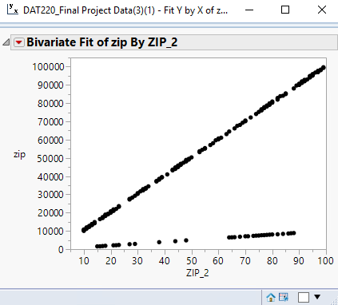
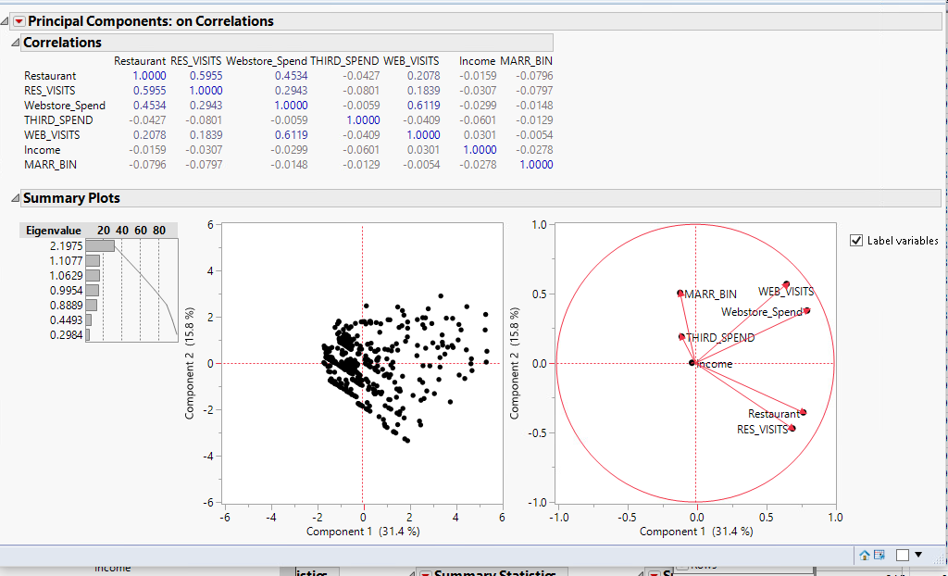
Sources of Error: There appear to be deficiencies in the third-party data – I do not understand what metrics a third-party vendor would use to determine the large number of third-party visitors that made no purchase. Without further understanding, the third-party data as a whole is kind of suspect. Running bivariate matrix on all of the columns also reveals an error in the encoding of zip-2’s for zip codes with a leading zero. Zip-2’s are directly derived from the zip code so that should be a perfectly linear relationship, though we can tell at a glance of the graph that this is not the case. This can be fixed by deleting the second digit of the zip-2 for the affected rows.
Meaningful Patterns:
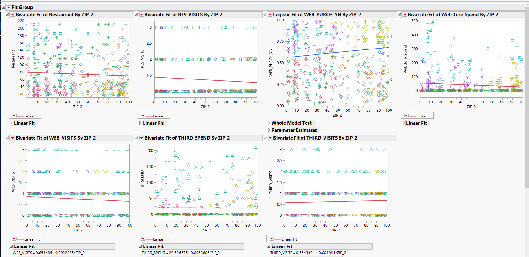
- Continuing along the lines of geography and zip, we can see that the further west we look (the higher the zip-2 value), Bubba Gump tends to have fewer customers, though it is these western customers that tend to shop online more as well as make more third-party purchases.
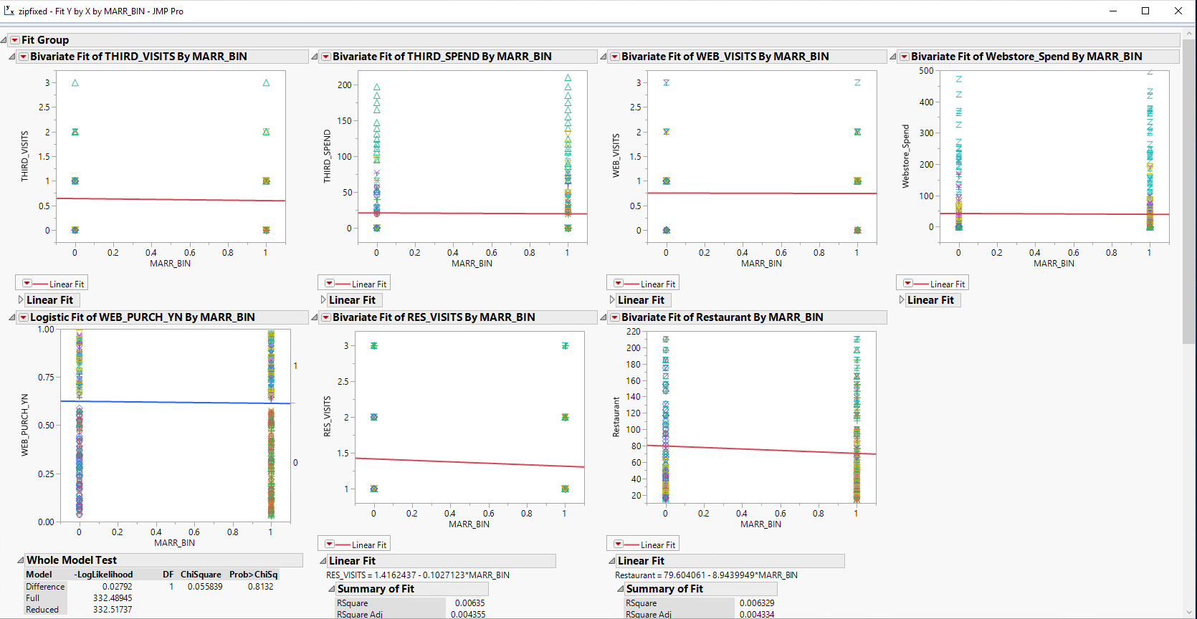
- Interestingly, marriage status does not seem to hold great weight. On everything except web visits and web spending, there is a slight downtick in favor of single customers. This is important as it suggests the customer-base does not think of Bubba Gump as a family-style restaurant, which means advertising should not focus on that unless they are actively trying to rebrand the restaurant.
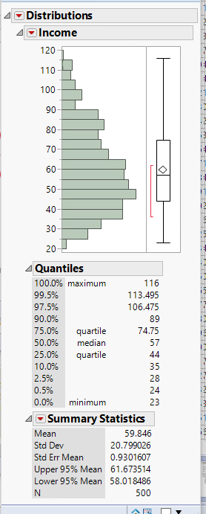
- We’ve seen from the PCA that the higher income customers are not the base customer. Customers range in income from $23,000 to $116,000, but the bulk of customers are solidly middle-class with incomes in the $45,000-$60,000 range.

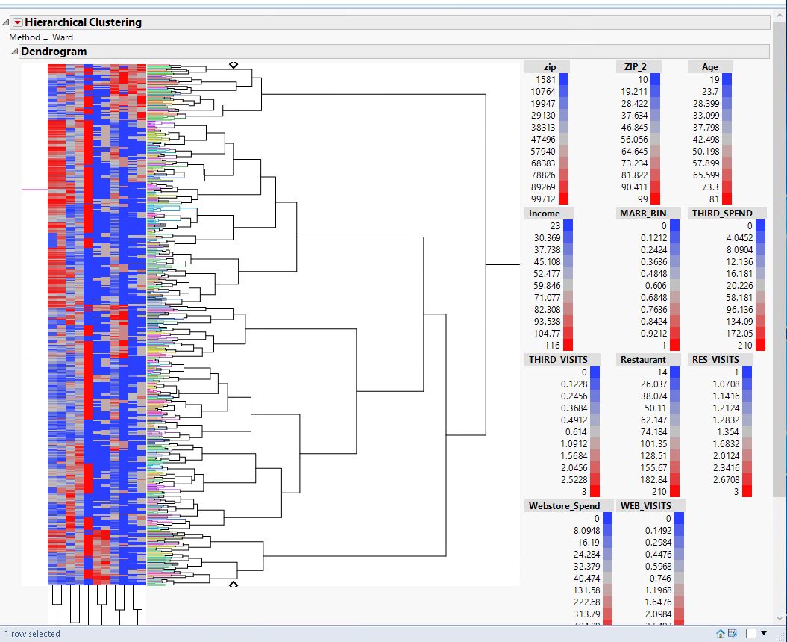
- Web purchasers fall into a natural cluster as well, and the biggest key to web purchases is actually bringing the customer into the restaurant first, and the more repeat restaurant visits, the more the online sales. Web purchasers seem to be lower 40’s in age, 60k salary, with zip-2’s in the 4x and 5x regions.
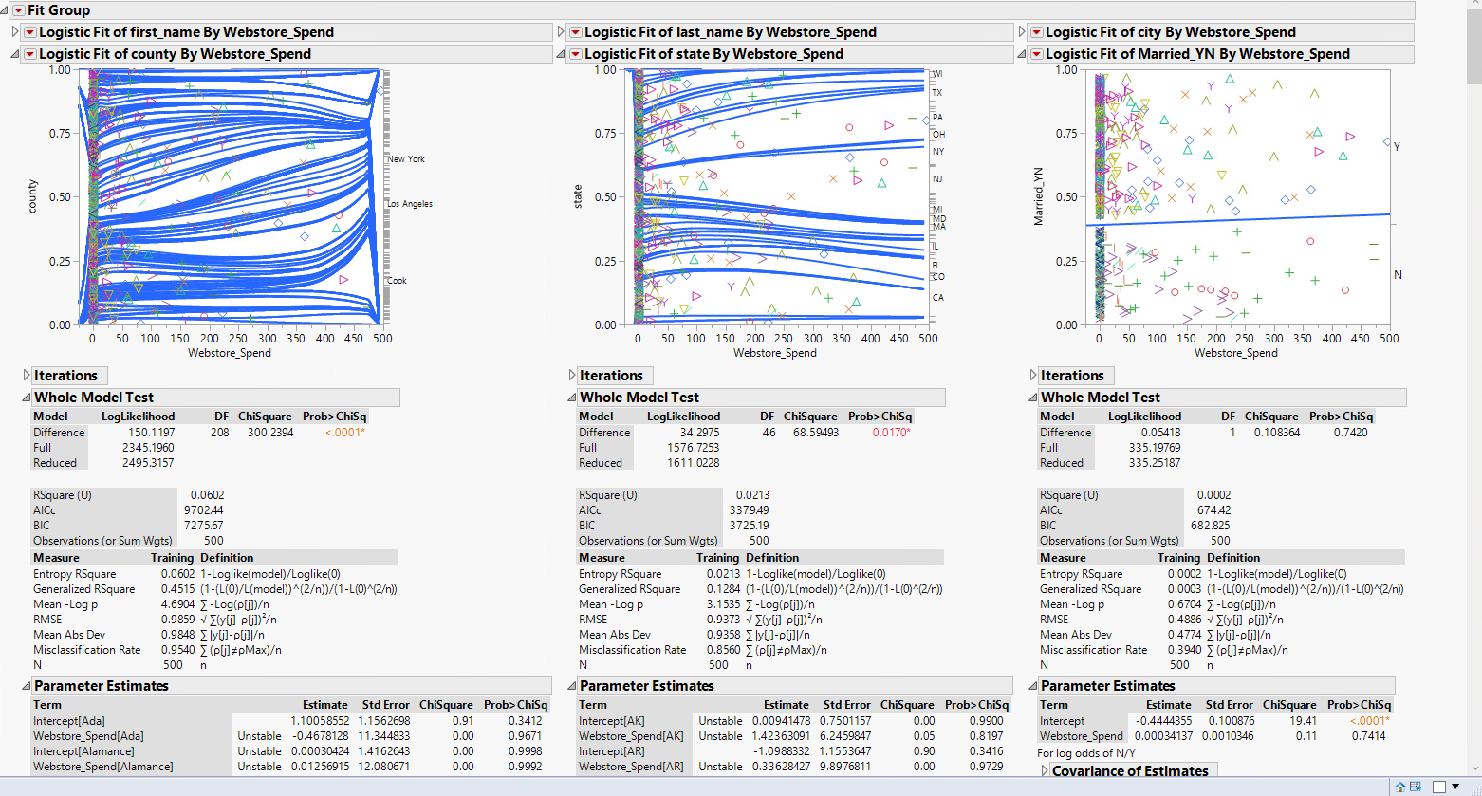
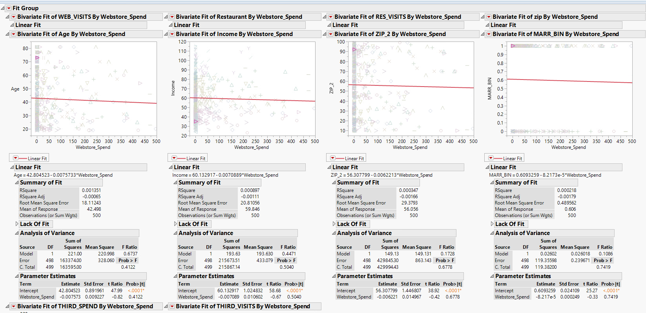
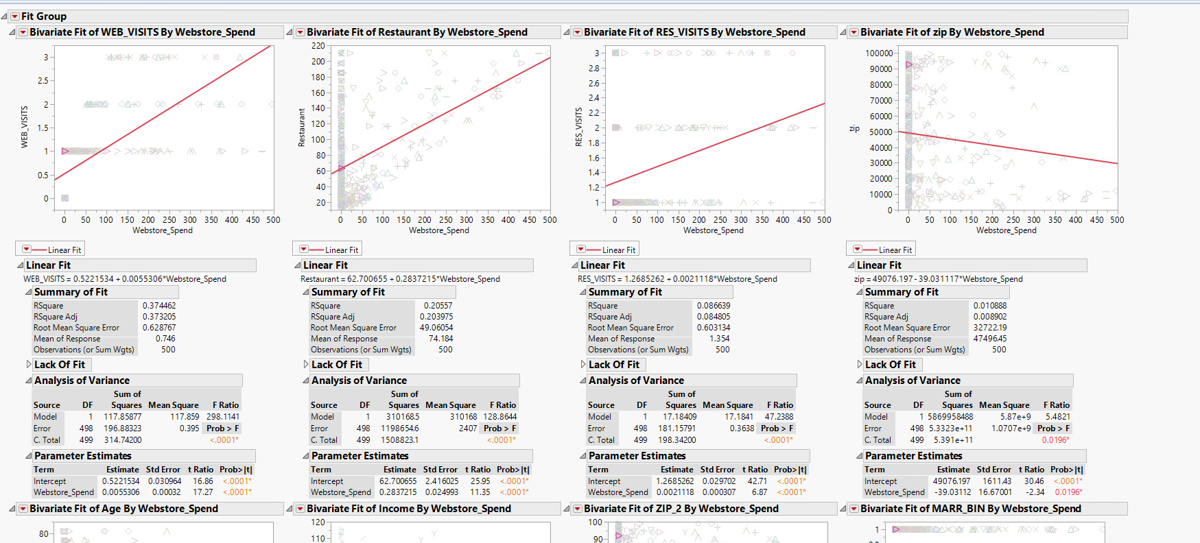
In the end, it seems web purchases are very much tied to geographic region. Big market cities, of course, but otherwise focused in on the 4x and 5x zips in the middle of the country.
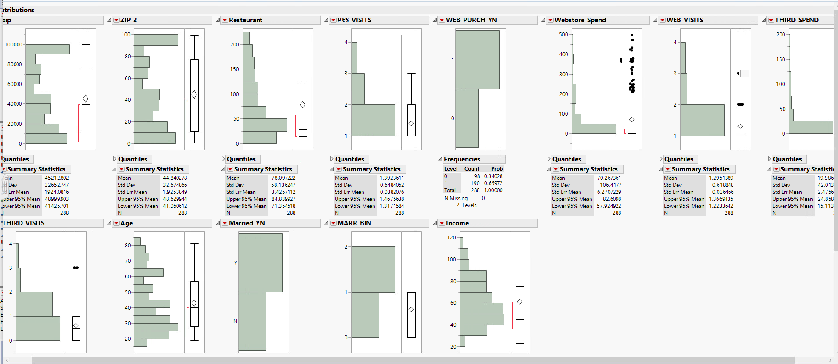
Inaccurate Depictions of Data: Most of all, I do not trust the third-party information as I do not understand why third-party visits without purchases are being reported nor how that can be determined or reported. Otherwise, web purchases can be a bit skewed as customers who have never visited the website are still being reported as a web_spend of 0. This is helpful in the long run, but will skew the data. We can alleviate this by selecting all the records with a web_visit > 0 and exclude other records, or copy/paste into a new database, and then analyzing this new/excluded database to analyze website purchases with greater accurate. This can be interesting as the web shopper demographic is different from that of the restaurant itself – as in much, much more likely to be married.
Alternative Analytic Methods: Other methods can involve increasing dataset sizes or further drilling into more niche subsets like the excluded table of web purchasers above. We can also apply decision trees and neural networks to evaluate the data, though unfortunately I do not really get neural networks yet.
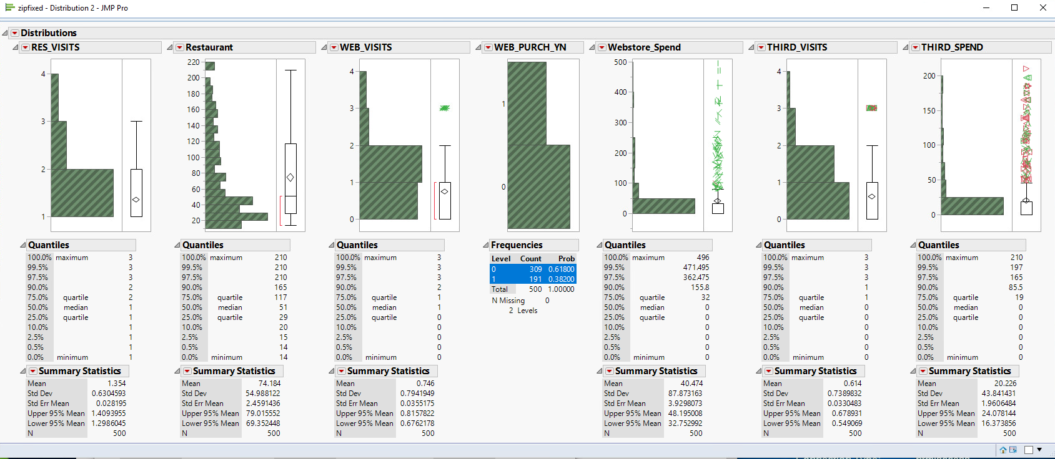
Display and Interpretation: Looking at the three avenues of income (restaurant, website, and third-party vendors), it seems obvious that getting people into the restaurant is key as website and third-party purchases are all reliant on their being an initial restaurant visit.
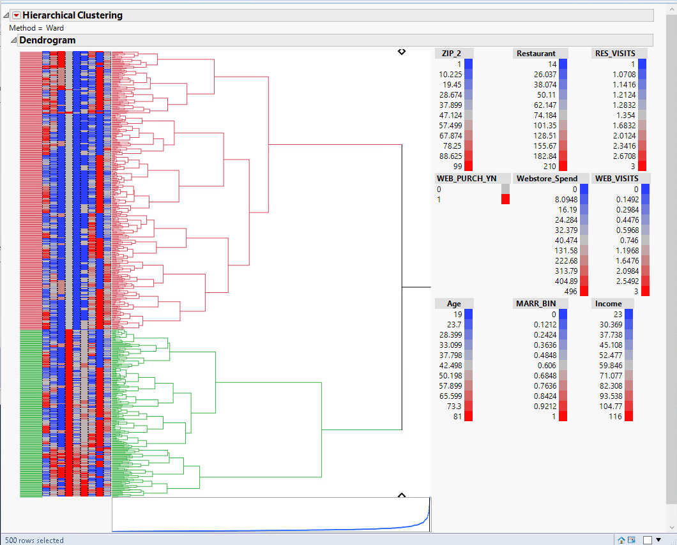
Focusing in on just people who actually make web purchases, the cluster marked in green, we can see web shopper demographics – income column is predominantly grey, so: fairly middle class, probably married, and age seems to be grey with a blue tendency.

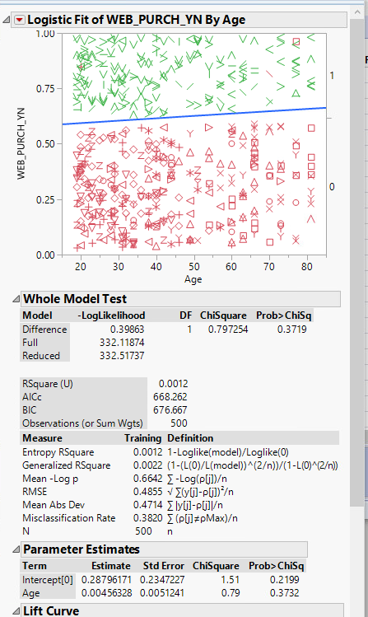
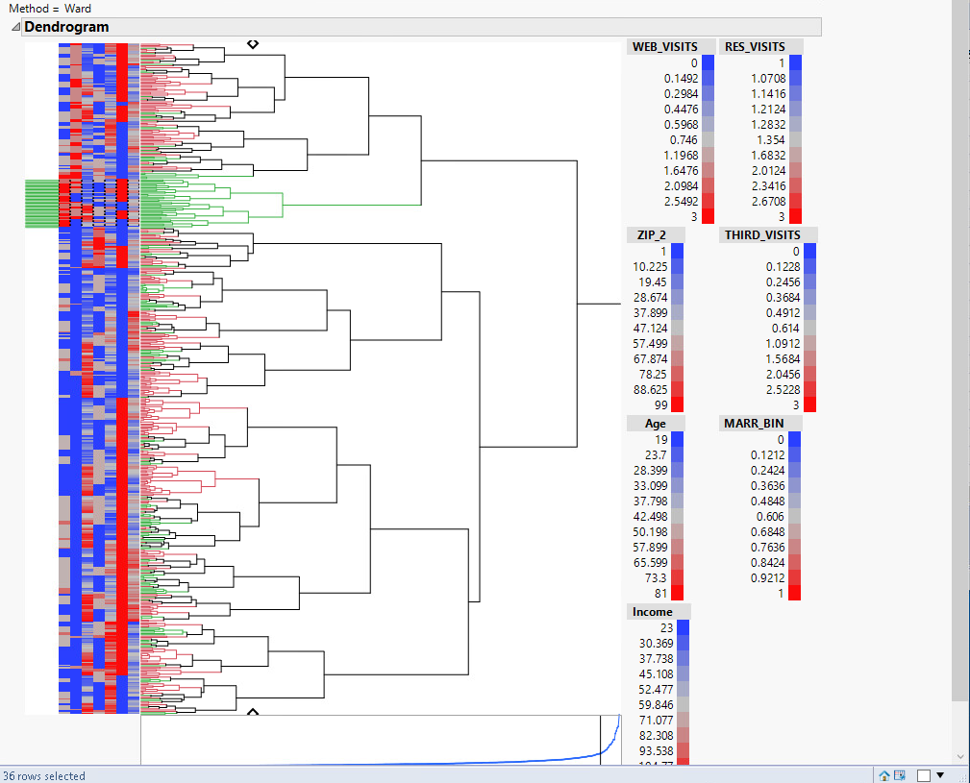
Focusing in on age of web purchasers, we can see around 46-47 is the ideal customer – people who were in their early 20’s at the time of the Forrest Gump movie (1994).

What’s also interesting is looking at those likely to even look at the website in the first place. There is a definite tendency for website visitors to be married.
Third-party shoppers are also clustered and tend to visit the website less as well as more likely to be single.

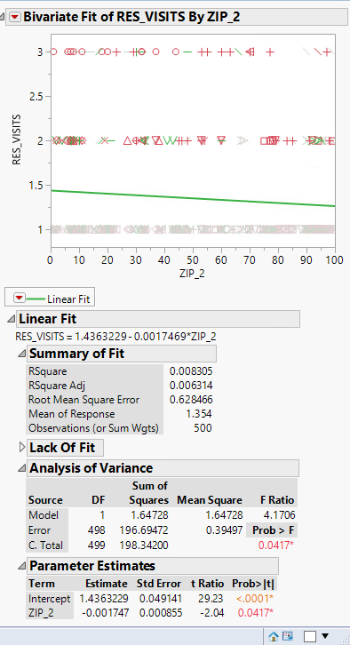
The key is getting the customers into the restaurant. Once in the restaurant, families can be targeted with website advertisements while single customers can receive a mix of website and third-party advertisements.
Another interesting tidbit is looking at repeat restaurant visits. The further east (lower numbered zip-2) we look, the more likely we are to have repeat restaurant visitors. This is despite the fact that our target customer base is in the 4x/5x zip codes. Therefore, it is probably worthwhile taking a deeper look at the 0x-2x restaurants to see what they are doing to bring in the repeats and then applying those strategies in the 4x-5x zips where we are more likely to get customers in the first place.
Validity, Reliability, Limitations: At this point, everything must be taken with a grain of salt. The sample set that we worked with is a sample of 500 customers. On its own, we have no idea if this dataset is truly representative of the larger dataset or if there are anomalies. The analyses have to be externally validated – run against multiple samplings from the original Bubba Gump dataset – in order to rule out anomalous data. As stated earlier, I don’t understand the logic of how the third-party vendor values were generated so I hold that data with some suspicion. The rest of the data originates with Bubba Gump, who has a vested interest in extracting information from this data, so I’d assume some level of goodness to the data. I feel like the primary limitation from Bubba Gump’s data though is simply that we were provided with a limited subset of data and that the sources listed suggests there is far more depth of data available – things like individual purchase data, times of visits, actual restaurant visited, actual restaurant locations, etc. Clarification to the data would also be helpful, knowing with certainty what labels apply to columns (such as income as thousands of dollars) or knowing for certain that the dataset is only domestic sales and does not include the international restaurants.
Resulting Decision Influence: Depending on the client/supervisor, if they are not adept at reading data, then the presentation would be more akin to a PowerPoint rather than the images I’ve been portraying which show more of the gestalt. Assuming the information has been externally tested for validity, it is worthwhile to find out what those predominantly eastern restaurants are doing to bring in repeat customers. If we can pair this information with restaurant locations, that will give us a better overall picture. This can help with targeted advertising, or even potential locations for restaurants. If we have money to burn, helping get a Forrest Gump sequel movie out that will appeal to younger crowds would probably help out quite a bit. I’m not sure of what time basis the sample set is involved with, but if these are historical records for a long period of time, that no one has visited the restaurant more than 3 times suggests the movie has a vast hold on the clientele and the restaurant needs to do more to get taken seriously as a restaurant in its own right and not so reliant on the movie.
Visual Evaluation: Personally, I like visuals that have lots of information so the viewer can make the same conclusions and see where they came from. From what I’ve seen though, presenting information to casual viewers and decision makers should really be pared down to the most salient image-bytes – prove yourself as an analyst and they don’t need to see the how and why, just the what.
Next Steps: First next step of course should be the external testing. Further lines of inquiry though can be to figure out why certain restaurants are better at bringing repeat customers; using distance from physical restaurants, we can look to see who is actually a local customer and who is on vacation or making a special trip; further third-party details are very much needed as I have too many questions about the data itself to be able to put much stock into its usefulness; being able to look at a more detailed dataset, we could look closer at restaurant and website purchases, get a better sense of how close in time to restaurant visits lead into web purchases, are web purchases more likely closer to holidays or is that unrelated. I’d hesitate to make any recommendations for immediate action as I would want the data externally validated before I’d feel comfortable with that. Assuming we can rule out that our dataset is anomalous, it seems like a natural fit to market Bubba Gump as a business lunch location. 0x-2x restaurants are bringing in the repeat customers, so those need studied to see what is bringing customers back. While not a family restaurant per se, there is still a sizable number of married customers – so these need analyzed to see if they are visiting as a family or as individual family members in a social outing. While there is not a heavily married population, the website purchases are heavily married, which I think still tends towards a business lunch setting with people inspired to make web purchases of paraphernalia for family.

